Software Requirements Specification (SRS) for ResolveIT
Introduction
ResolveIT is an IT ticketing system that allows end users to create support tickets while enabling IT staff to track, assign, and resolve issues efficiently. The system aims to streamline IT support operations and improve response times.
Scope
ResolveIT will be a web-based application Ticket Management System (TMS) it will include features for ticket management, user roles, and real-time updates to ensure smooth IT operations.
Intended Audience
- IT Support Teams
- System Administrators
- End Users
Technologies Used
- Frontend: Vue.js, PrimeVue UI Library.
- Backend: Laravel
- Database: MySQL
- Authentication: csrf cookies
- Hosting: Docker or general PHP server like Apache or Nginx
Functional Requirements
User Roles
- End User: Can create tickets, view status updates and communicate with IT Support.
- End User Group leader: Same as end user but can also manage users in group.
- IT Staff: Can assign tickets, update statuses, and resolve issues.
- Admin: Can manage users, oversee ticket flow, and configure settings.
Ticket Management
- Users can create tickets with details about their issue.
- IT staff can view all open tickets.
- IT staff can assign tickets to themselves or a team.
- Ticket statuses: Open, In Progress, Resolved, Closed.
- Users receive notifications on status updates.
UML Diagrams

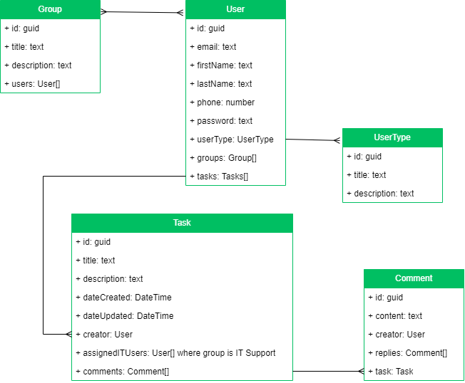
Constraints & Assumptions
- The system will require an internet connection.
- Only registered users can create and manage tickets.
- Initial deployment will support a single organization; multi-tenancy may be considered in future versions.
Future Enhancements
- Integration with email, teams and slack.
- Mobile app for ticket management.
- AI-based ticket categorization and assignment.

